Name: Muhammad Shoaib Khan

Seat Number: B12101087

Class: BSCS 2nd Year (Section A)

**Object-Oriented Programming**

**(Assignment 2)**

**Subject: Write a program in C# using command line interface to ask the user two integers values and two floating point values. Perform basic arithmetic operations on both data types.**

using System;

using System.Collections.Generic;

using System.Linq;

using System.Text;

using System.Threading.Tasks;

namespace Assignment_3

{

class Program

{

static void Main(string[] args)

{

int a=0, b=0;

float fnum1,fnum2;

string c, d;

Console.WriteLine("Enter 2 int variables: ");

a = Convert.ToInt32(Console.ReadLine());

b = Convert.ToInt32(Console.ReadLine());

Console.WriteLine("Your 2 int variables are {0},{1}", a, b);

Console.WriteLine("The sum of the the two integers is: ");

Console.WriteLine("{0} + {1} = {2}",a,b,a+b);

Console.WriteLine("The subtraction of the two integers is: ");

Console.WriteLine("{0} - {1} = {2}", a, b, a - b);

Console.WriteLine("The multiplication of the two integers is: ");

Console.WriteLine("{0} * {1} = {2}", a, b, a * b);

Console.WriteLine("The division of the two integers is: ");

Console.WriteLine("{0} / {1} = {2}", a, b, a / b);

Console.WriteLine("Enter 2 float variables: ");

c = Console.ReadLine();

d = Console.ReadLine();

fnum1 = float.Parse(c);

fnum2 = float.Parse(d);

Console.WriteLine("Your 2 int variables are {0},{1}", fnum1, fnum2);

Console.WriteLine("The sum of the the two integers is: ");

Console.WriteLine("{0} + {1} = {2}", fnum1, fnum2, fnum1+fnum2);

Console.WriteLine("The subtraction of the two integers is: ");

Console.WriteLine("{0} - {1} = {2}", fnum1, fnum2, fnum1 - fnum2);

Console.WriteLine("The multiplication of the two integers is: ");

Console.WriteLine("{0} * {1} = {2}", fnum1, fnum2, fnum1 * fnum2);

Console.WriteLine("The division of the two integers is: ");

Console.WriteLine("{0} / {1} = {2}", fnum1, fnum2, fnum1 / fnum2);

Console.ReadKey();

}

}

}

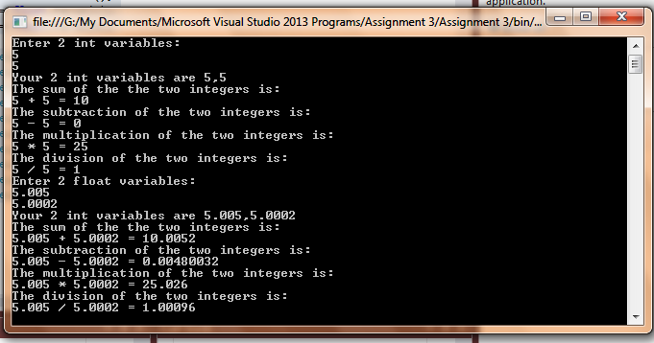

**ASSIGNMENT-1**

due February 17

**To Study basic digital concepts: Waveforms, Logic Levels, Lab Instruments, Integrated Circuits etc. Write the brief paragraph about each tool and instrument and attach it. Paste the diagram of the equipment also. Use your own handwriting.**

Chapter-1 of Book (Floyd) should be studied.  
Supporting slides could be downloaded through ClassJump.

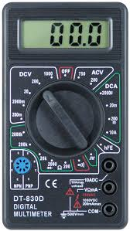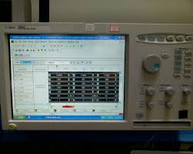

**Digital Multimeter Logic Analyzer**

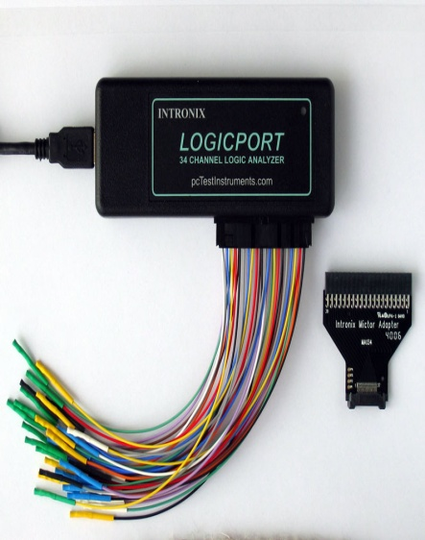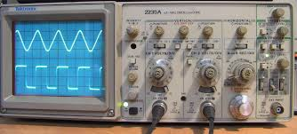

**Logic Analyzer Probe Oscilloscope**

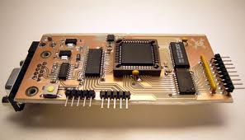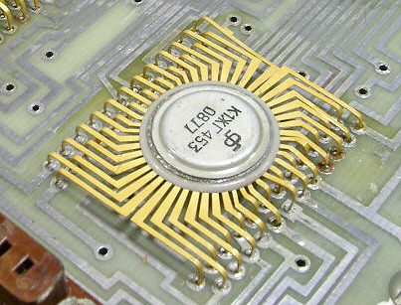

**Programmable Logic Devices Integrated Circuit 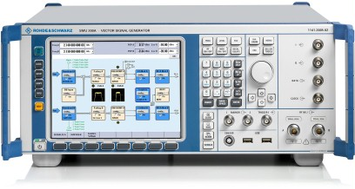 Signal Generator**